CLASS: XII SUBJECT : BIOLOGY
CHAPTER WISE WORKSHEET
INDEX
SN. | CHAPTER’S NAME | PAGE NO.
1. | Ch-1: Sexual Reproduction in Flowering Plants | 2 - 4
2. | Ch-2: Human Reproduction | 5 -7
3. | Ch-3: Reproductive Health | 8 -9
4. | Ch-4: Principles of Inheritance and Variation | 10 - 11
5. | Ch-5: Molecular Basis of Inheritance | 12 - 15
6. | Ch-6: Evolution | 16 - 18
7. | Ch-7 Human Health and Diseases | 19 - 23
8. | Ch-8: Microbes in Human Welfare | 24 - 26
9. | Ch-9: Biotechnology - Principles and Processes | 27 - 32
10. | Ch-10: Biotechnology and its Applications | 33 -35
11. | Ch-11: Organisms and Populations | 36 - 38
12. | Ch-12: Ecosystem | 39 - 41
13. | Ch-13: Biodiversity and its Conservation | 42 - 44

WORKSHEET CHAPTER:1 - SEXUAL REPRODUCTION IN FLOWERING PLANTS

CLASS:XII Subject – Biology

ROLL NO.____NAME:______________ DATE:____/____/___ MARKS OBTAINED:_______

TIME: 35 MINUTES MM: 20

Multiple choice Questions (1 mark each)
Q.1 | Commelina has  (a)Only cleistogamous flower  (b) Only chasmogamous flowers  (c) Both of above  (d) No flowers
Q.2 | In which of the following plants , male and female flowers grow on separate plants to ensure cross pollination  (a) Cucumber (b) Sunflower  (c)Papaya (d)Maize
Q.3 | Sticky / spiny pollen grains and large, brightly colored, fragrating flowers are associated with  (a) pollination by wind(b) pollination by insects  (c) pollination by water(d) pollination by cattle
Q.4 | Persistentnucellusis called as ……………….. and it’s found in ……………..  (a) Testa, beetle (b)Endosperm, balck pepper  (c)Nucellus, ground nut (d)Perisperm, black pepper
Q.5 | Pollen grain is to anther as ………………. Is to ovule  (a) Embryo sac (b) Endosperm  (c) egg cell (d) synergids.
Q.6 | Emasculation and bagging respectively prevent unwanted  (a) Self pollination, Cross pollination (b) Self pollination only  (c) Cross pollination only (d) Cross pollination, Self pollination
Q.7 | Germ pore is the aperture  (a) in pollen grain from where gametes come out  (b) in embryo sac from where pollen tube enters  (c) in pollen grain from where pollen tube comes out  (d) in ovule from where pollen tube enters  Assertion Reason type questions (1x3)
Instruction:- In the following questions, a statement of assertion is followed by a statement of reason. Mark the correct choice as:-
(a) If both Assertion and Reason are true and Reason is the correct explanation of Assertion.
(b) If both Assertion and Reason are true but Reason is not the correct explanation of Assertion.
(c) If Assertion is true but Reason is false.
(d) If both Assertion and Reason are false.
Q.8 | Assertion:Pollen mother cell in pollen chamber undergoes mitosis to form 4 microspores.  Reason:Out of 4, three microspores degenerate and only one remains functional.  Answer:____________________________________________
Q.9 | Assertion: In angiosperms after fertilization endosperm grows faster than embryo .  Reason:Endosperm provides nourishment to the growing embryo.  Answer: ____________________________________________
Q.10 | Assertion: Some plants like Oxalis and Commelina produce chasmogamous and cleistogamous both types of flowers.  Reason: In chasmogamous flowers chances of cross pollination are more.  Answer: ___________________________________________
Q.11 | Pollen grains of a large number of species can be stored in liquid nitrogen or fossilised for years.  Give suitable reason for the statement. (2)  Answer:________________________________________________
 | ___________________________________________________________
Q.12 | Observe the figure given below and answer the questions:  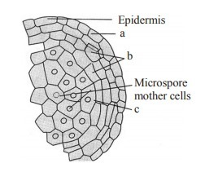  - Label parts a, b and c.  - What will happen if c will not work properly? (2)  Answer: ___________________________________________  __________________________________________________
Q.13 | Continuous self-pollination causes reduction in good quality characters. Which term is used for this phenomena. State any two mechanisms by which plants can prevent this situation. (2)  Answer:___________________________________________________  _________________________________________________________
Q.14 | Observe the figure given below and answer all questions from 1 (i) to (iv) given below:- (4)  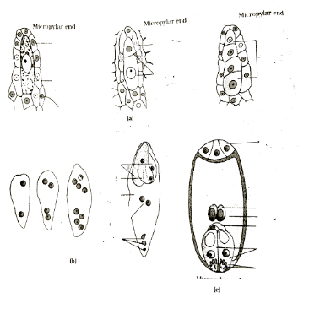  - Which process is shown in above figure?  - What can be the possible reason behind degeneration of 3 megaspores out of 4?  (iii) The structure shown in figure C is called as 7 celled , 8 nucleated. Explain.  - What is the role of filiform apparatus shown in figure c?  Answer: (i)_______________________________________________
(ii)________________________________________________
(iii)__________________________________________________

CHAPTER:2 - HUMAN REPRODUCTION

Worksheet class :12 Subject - Biology
TIME: 35 MINUTES MM: 20
ROLL NO._______ NAME:___________DATE:____/____/_____MARKS OBTAINED:_____
Multiple choice Questions (1 mark each)
1. | Developing male gametes in humans get nourishment from  (a) Germinal cells  (b)Sertoli cells  (c)Interstitial cells  (d)Spermatogonium
2. | Stage of differentiation in spermatogenesis is  (a) Spermiation (b) Spermetagenesis  (c)Spermiogenesis (d) None of above
3. | At which stage of female gamete ovulation occurs?  (a) Oogonium(b) Primary oocyte  (c) Secondary oocyte(d) Ovum
4. | Implantation occurs in……………….part of female reproductive system at ……………..embryonic stage.  (a) Ovary, Morula (b)Uterine wall, zygote  (c)Uterine wall, Blastocyst(d) Cervix, Blastocyst
5. | Which out of the following hormones secreted by placents only?  (a) Progesteron, hCG (b) Estrogen, hPL  (c) Relaxin, progester (d) Hcg, Hpl, Relaxin
6. | Hormone involved in parturition is  (a) Oxytocin (b) Relaxin  (c) FSH (d)All of above
7. | Which part of sperm provides energy for movement  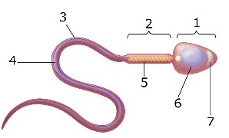  (a) part 1 (b) part 7(c) part 3 (d) part 5  Assertion Reason type questions (1x3)
Instruction:- In the following questions, a statement of assertion is followed by a statement of reason. Mark the correct choice as:-
(a) If both Assertion and Reason are true and Reason is the correct explanation of Assertion.
(b) If both Assertion and Reason are true but Reason is not the correct explanation of Assertion.
(c) If Assertion is true but Reason is false.
(d) If both Assertion and Reason are false.
8. |  | Assertion:In human males testis lie in scrotal sac.  Reason:Scrotal sacs are extra abdominalsacs having temperature lower than that of body cavity.  Answer:__________________________________________________
9. |  | Assertion: After bleeding phase of menstrual cycle proliferative stage starts.  Reason:After bleeding phase repauir and proliferation of endometrial lining occurs.  Answer:________________________________________________
10. |  | Assertion: Spermatids produced during spermatogenesis are diploid structures.  Reason: Spermatids undergo meiosis to produce haploid sperms.  Answer:__________________________________________________
11. |  | From where first signal for the birth of baby generates in human female? Which technical term is used for this ? (2)  Answer: __________________________________________________________________________________________________________________________________________________________________________________________________________________________________________________________________________________________________________________________________________________________________________________________________________________________________________
12. |  | Observe the figure given below and answer the questions (2)  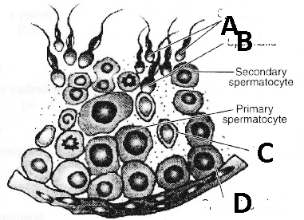  - Label A and B.  - What will be the ploidy level of D cells?  Answer:(a)_A________________________B____________________  (b)______________________________________________________
13. |  | Answer the following questions: (3)  - At which stage of menstrual cycle progesterone level remains highest?  - On 15 – 17 day level of LH remains very high. Which term is used for this condition? What is the importance of this condition?  - What happens with the empty graafian follicle? What is the importance of it?  Answer (i)____________________________________________________________________________________________________________________  (ii)____________________________________________________________________________________________________________________  (iii)____________________________________________________________________________________________________________________________________________________________________________
14. How placenta formation occurs in human female? Explain it’s secretory role in brief. (3)
Answer :_________________________________________________________________________________________________________________________________________________________________________________________________________________________________________________________________________________________________________________________________________________________________________________________________________________________________________________________________________________________________________________________________________________________________________________________________________________________________________________________________________________________________________________________________________________________________________________________________________________________________________________________________________________________________________________________________________________________________________________________________________________________________________________________________________________________________________________________________________________________________________________________________________________________________________________________________________________________________________________________

CHAPTER3:REPRODUCTIVE HEALTH WORKSHEET CLASS :XII BIOLOGY
TIME:30 MINUTES MM:20 MARKS OBTAINED________
ROLL NO.__________NAME :____________ DATE :____/____/_____
QN. | QUESTIONS | MM
1. | Test tube baby implies which of the following techniques?  - IUI b. ICSI c. GIFT d. ZIFT | 1
2. | Which technique is used to detect AIDS?  - Northern blot and ELISA b. Immuno blot and ELISA  c.Western blot and ELISA d. Southern blot and ELISA | 1
3. | Study the diagram of human reproductive system given below. Answer the questions based on the diagram.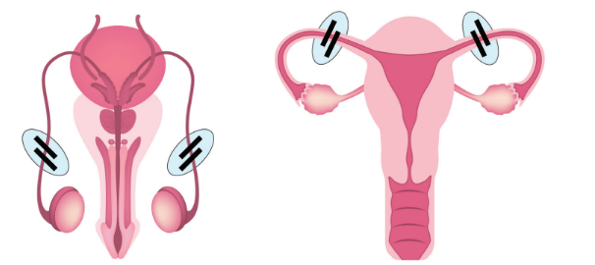(i)What does the diagram depict?  (ii) At what stage zygote can be introduced in the fallopian tube in Zygote Intra Fallopian Transfer (ZIFT)?  Answer: (i)__________________________________  - _____________________________________ | 2
4. | Directions: In the following questions, a statement of assertion is followed by a statement of reason.  Mark the correct choice as:  (a) If both Assertion and Reason are true and Reason is the correct explanation of Assertion.  (b) If both Assertion and Reason are true but Reason is not the correct explanation of Assertion.  (c) If Assertion is true but Reason is false.  (d) If both Assertion and Reason are false.  (i). Assertion: Reproductive and Child Healthcare Programmes is for reproduction related areas.  Reason: It deals with creating awareness among various reproduction related aspects.  Answer: ________________________________________  (ii). Asertion: Barrier methods prevent physical meeting of sperms and ova.  Reason: This prevents conception.  Answer:_____________________________________________ | 2
5. | A pregnant human female was advised to undergo MTP. It was diagnosed by her doctor that the foetus, she is carrying has developed from a zygote formed by an XX-egg fertilised by Y-carrying sperm. Why was she advised to undergo MTP?  Answer: ________________________________________  ______________________________________________________ | 2
6. | Why is tubectomy considered a contraceptive method?  Answer:____________________________________________________________________________________________________  ____________________________________________________________________________________________________________ | 2
7. | How does Cu-T act as an effective contraceptive for human females?  Answer:____________________________________________________________________________________________________  ___________________________________________________________________________________________________________ | 2
8. | A woman has certain queries as listed below, before starting with contraceptive pills. Answer them.  (i)What do contraceptive pills contain and how do they act as contraceptives?  (ii)What schedule should be followed for taking these pills?  Answer(i)____________________________________________________________________________________________________  (ii)________________________________________________________________________________________________________ | 3
9. | (a). Describe the technique which is used for sex determination in foetus?  Answer:_________________________________________________________________________________________________________________________________________________________________________________________________________________  (b) . Give another name for sexually transmitted diseases. Name two sexually transmitted diseases which are curable and two diseases which are not curable.  Answer:_______________________________________________  _____________________________________________________ | 5

WORK SHEETCHAPTER:4 “PRINCIPAL OF INHERITANCE AND VARIATION”

TIME: 30 MINUTES CLASS : XII BIO MM: 20 DATE:____/_____/______

ROLL NO. _____________NAME OF STUDENTS:____________________ MARKS OBTAINED:_____

1.Mongolism is a genetic disorder which is caused by the presence of an extra chromosome number--------------------------------------------------------------------------- 1
(a) 20(b) 21(c) 17(d) 23
ANSWER:____________________
2.Klinefelter’s syndrome is characterised by a karyotype of------------------------- 1
(a) XYY(b) XO(c) XXX(d) XXY
ANSWER:________________________
3.What can be the blood group of offspring when both parents have AB blood group ?------1
(a) AB only(b) A, B and AB(c) A, B, AB and O(d) A and B only
ANSWER________________________
4.Garden pea plant produced round, green seed. Another of same species produced wrinkled yellow seeds. Identify dominant traits. --------------------2

ANSWER:____________________________________________________________________________________________________________________________________________________________________________________________________________________________________________________________________

5.Mention two contrasting flower related traits studied by Mendel in pea plant experiments. -------------------------------------------------------------------------2
6. Name the kind of diseases/disorders with symptoms that are likely to occur in humans if --------------------------------------------------------------------3
(a) mutation in the gene that codes for an enzyme phenylalanine hydrolase occurs,
(b) there is an extra copy of chromosome 21,
(c) the karyotype is XXY.
ANSWER:______________________________________________________________________________________________________________________________________________________________________________________________________________________________________________________________________________________________________________________________________________________________________________________________________________________________________________________________________________________________________________________________________________________________________________________________________________________________________________________________________________________

7.Identify a, b, c, d, e and / in the table given below:-------------------------- 5
Syndrome | Cause | Characteristics of affected individual | Sex Male/ Female/ Both
Down’s | Trisomy of 21 | a (i), (ii) | b
c | XXY | Overall masculine development | d
Turner’s | 45 with XO | e (i) (ii) | f
ANSWER:____________________________________________________________________________________________________________________________________________________________________________________________________________________________________________________________________________________________________________________________________________________________________________________________________________________________________________________________________________
8.A cross between a normal couple resulted in a son who was haemophilic and a normal daughter. In course of time, when the daughter was married to a normal man, to their surprise, the grandson was also haemophilic.--------------------------------5
(i) Represent this cross in the form of a pedigree chart. Give the genotypes of the daughter and her husband.
(ii) Write the conclusion you draw from the inheritance pattern of this disease.
ANSWER:(i) ___________________________________________________________________

________________________________________________________________________________
(ii)___________________________________________________________________________________________________________________________________________________________________________________________________________________________________________________________________________________________________________________________________________________________________________________________________________________________________________________________________________________

WORKSHEET CHAPTER:5 “ MOLECULAR BASIS OF INHERITANCE”
CLASS : SUBJECT : BIOLOGY
ROLL NO. _________NAME _______________ MARKS OBTAINED___

TIME:30 MINUTES MM:20 DATE :_____/______/______
1.Nucleic acids are polymer of------------------------------------- 1
(a) Nucleosides
(b) Proteins
(c) Glycoproteins
(d) Nucleotides
Answer: _______________________

2.Directions: In the following questions, a statement of assertion is followed by a statement of reason.----------------------------------------------------------------------- 1
Mark the correct choice as:
(a) If both Assertion and Reason are true and Reason is the correct explanation of Assertion.
(b) If both Assertion and Reason are true but Reason is not the correct explanation of Assertion.
(c) If Assertion is true but Reason is false.
(d) If both Assertion and Reason are false.
Assertion: The two chains of DNA have anti-polarity.
Reason: In one chain of DNA, ribose sugar at 5′ end consists of a free phosphate moiety while at the other end the ribose has a free 3′ OH group.
Answer: _________________________________________________________________________________________________________________________________________________________________________________________________________________________________

3.Case Based Questions:--------------------------------------------- --------------------1
Given below is the diagram of a tRNA molecule.
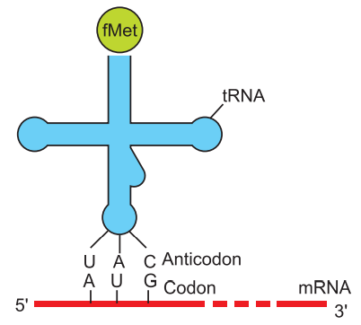
Answer the questions based on the above diagram:
(i) Where does peptide bond formation occur in a bacterial ribosome?
(ii) Name the scientist who called tRNA an adaptor molecule.
Answer(i)_____________________________________________
(ii)_________________________________________________
4.Why does hnRNA undergo splicing? Where does splicing occur in the cell? ------------2
Answer______________________________________________________________________________________________________________________________________________________________________________________________________________________________________________________________________

5.A structural gene has two DNA strands X and Y shown along side. Identify the template strand. ------------------------------------------------------------------------ 2
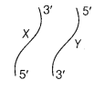
Answer:_________________________________________________________________________________________________________________________________________________________________________________________________
6.Show DNA replication with the help of a diagram only.--------------------------2
Answer:

7.Describe the structure of a nucleosome. ----------------------3
Answer: ________________________________________________________________________________________________________________________________________________________________________________________________________________________________________________________________________________________________________________________________________________________________________________________________________________________________________________________________

8.Answer the questions based on the dinucleotide shown below.---------------- 3
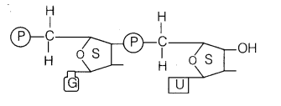
(i) Name the type of sugar guanine base is attached to.
(ii) Name the linkage connecting the two nucleotides.
(iii) Identify the 3′ end of the dinucleotide. Give a reason for your answer. (All India 2010C)
Answer:
(i) _________________________________________________________________________ (ii) _________________________________________________________________________
(iii_______________________________________________________________________

9.How did Hershey and Chase established that DNA is transferred from virus to bacteria? -5
Answer : ____________________________________________________________________________________________________________________________________________________________________________________________________________________________________________________________________________________________________________________________________________________________________________________________________________________________________________________________________________________________________________________________________________________________________________________________________________________________________________________________________________________________________________________________________________________________________________________________________________________________________________________________________________________________________________________________________________________________________________________________________________________________________________________________________________________________________________________________________________________________________________________________________________________________________________________________________________________________________________________________________________________________________________________________

SPACE FOR DIAGRAM ( Q.9 )

WORK SHEET CLASS : XII BIOLOGY CHAPTER 6: “EVOLUTION”
ROLL NO. ____________ NAME_______________ DATE:____/____/_____
TIME: 30 MINUTES MM: 20 MARKS OBTAINED:________
1.The primate which existed 15 mya was-------------------------------------------------- 1
(a) Homo habilis
(b) Australopithecus
(c) Ramapithecus
(d) Homo erectus
Answer:_______________________________
2.Directions: In the following questions, a statement of assertion is followed by a statement of reason.--------------------------------------------------------------------------------------- 1
Mark the correct choice as:
(a) If both Assertion and Reason are true and Reason is the correct explanation of Assertion.
(b) If both Assertion and Reason are true but Reason is not the correct explanation of Assertion.
(c) If Assertion is true but Reason is false.
(d) If both Assertion and Reason are false.
. Assertion : According to big-bang hypothesis about 20 billion years ago universe was a big ball of only neutrons.
Reason : Movement of these particles is known to generate tremendous heat which caused explosion due to temperature and pressure changes.
Answer: _______________________________________________

3.According to Hardy-Weinberg principle, the allele frequencies in a population are stable and remain constant through generations. When the frequency differs from the expected values, the difference indicates the extent (direction) of evolutionary change. Disturbance in the genetic equilibrium or Hardy-Weinberg equilibrium in a population can be interpreted as resulting in evolution.
Write the algebraic equation representing Hardy-Weinberg equilibrium.---1
Answer: ______________________________________
4.Why are analogous structures a result of convergent evolution? -------------------------- 2
Answer:______________________________________________________________________________________________________________________________________________________________________________________________________________________________________________________________________________________________
5. Identify the following pairs as homologous or analogous organs----------------------------- 2
(a) Sweet potato and potato.
(b) Eye of Octopus and eye of mammals.
(c) Thorns of Bougainvillea and tendrils of Cucurbita.
(d) Forelimbs of bat and whale.
Answer: (a) ________________________________________.
(b) ________________________________________________
(c) _______________________________________________
(d) _______________________________________________
6.According to Hugo de Vries what is saltation? ------------------------------------------------ 2
Answer:.____________________________________________________________________________________________________________________________________________________________________________________________________________________________________________________________________________________________

7.Name the ancestors of a man based on the features given below.------------------- 3
(i) Human-like, meat-eater with 900 cc brain, lived in Java.
(ii) More human-like with brain size 1400 cc, lived in Central Asia, used hides and buried their dead.
(iii) Human-like, vegetarian, with brain capacity between 650-800 cc.
Answer:(i) _______________________________________________
(ii) __________________________________________________
(iii) _________________________________________________
8.Given below is a diagrammatic representation of the experimental setup used by SL Miller for his experiment.---------------------------------------------------------------------- 3
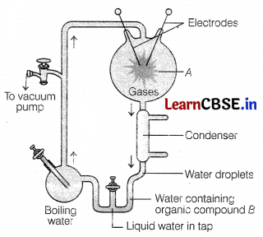
(i) Write the names of different gases contained and the conditions set for the reaction in the flask A.
(ii) State the type of organic molecule he collected in the water at B.
(iii) Write the conclusion he arrived at. (Delhi 2013C, Foreign 2011)
Answer( i)____________________________________________________
(ii)__________________________________________________________
(iii) ___________________________________________________________
9.Describe the three different ways by which natural selection can affect the frequency of a heritable trait in a population. -----------------------------------------5
Answer:________________________________________________________________________

__________________________________.

Work sheet chapter 7: “HUMAN HEALTH AND DISEASE”
CLASS : XII SUBJECT: BIOLOGY
ROLL NO. _______NAME : ____________ DATE: ___/____/___

TIME:30 MINUTES MM:20 MARKS OBTAINED________

QN. | QUESTIONS | MM
1. | Diseases are broadly grouped into infectious and non-infectious diseases.  In the list given below, identify the infectious diseases.  (i) Cancer (ii) Influenza (iii) Allergy (iv) Small pox  (a) (i) and (ii) (b) (ii) and (iii) (c) (iii) and (iv) (d) (ii) and (iv)  Ans. | 1
2. | Which technique is used to detect AIDS?  - Northern blot and ELISA b. Immuno blot and ELISA  c.Western blot and ELISA d. Southern blot and ELISA  Ans. | 1
3. | In malignant tumors, the cells proliferate, grow rapidly and move to other parts of the body to form new tumors. This stage of disease is called  - metagenesis (b) metastasis (c) teratogenesis (d) mitosis  Ans. | 1
4. | Which of the following are the reason(s) for rheumatoid arthritis? Choose the correct option.  (i) The ability to differentiate pathogens or foreign molecules from self cells increases.  (ii) Body attacks self cells  (iii) More antibodies are produced in the body  (iv) The ability to differentiate pathogens or foreign molecules from self cells is lost  (a) (i) and (ii) (b) (ii) and (iv)  (c) (iii) and (iv) (d) (i) and (iii)  Ans. | 1
5. | Which of the following antibodies form innate immunity?  - IgE (b) IgD (c) IgM (d) IgG  Ans. | 1
6. | Haemozoin is a  (a) precursor of hemoglobin  (b) toxin released from Streptococcus infectedcells  (c) toxin released from Plasmodium infected cells  (d) toxin released from Haemophilus infected cells  Ans. | 1
7. | Which of the following is not the causal organism for ringworm?  (a) Microsporum (b) Trichophyton  (c) Epidermophyton (d) Macrosporum  Ans. | 1
8. | In the following questions a statement of assertion followed by a statement of reason is given. Choose  the correct answer out of the following choices.  (a) Assertion and reason both are correct statements and reason is correct explanation for assertion.  (b) Assertion and reason both are correct statements but reason is not correct explanation for assertion.  (c) Assertion is correct statement but reason is wrong statement.  (d) Assertion is wrong statement but reason is correct statement.  Assertion : Second infection of the same pathogen is quickly eliminated.  Reason : Preformed memory B and T-cells elicit a quick and vigorous attack on pathogens.  Ans. | 1
9. | Assertion : Proto-oncogenes are cellular genes required for normal growth.  Reason : Under certain conditions they lead to the oncogenic transformation of the cell.  Ans. | 1
10. | Retroviruses have no DNA. However, the DNA of the infected host cell does possess viralDNA. How is it possible?  Ans: __________________________________________________________________________________________________________________________________________________________________________________________________________________________________________________________________________________________________________________________________________________________________________________________________________________________________________________________________ | 1
11. | What is cancer? How is a cancer cell different from normal cell?  Ans: __________________________________________________________________________________________________________________________________________________________________________________________________________________________________________________________________________________________________________________________________________________________________________________________________________________________________________________________________ | 2
12. | You have attended a birthday party hosted by one of your classmates. You found some guestsat the party sitting in a corner making a lot of noise and consuming ‘something’. After awhile one of the boys from the group started screaming, behaving abnormally and sweating  profusely. On enquiry you found that the group members were taking drugs.  - Would you inform your parents/school authorities? Yes/No. Give reasons is support ofyour answer.  Ans: __________________________________________________________________________________________________________________________________________________________________________________________________________________________________________________________________________________________________________________________________________________________________________________________________________________________________________________________________  - Write any two ways that you will suggest to your school principal so as to promoteawareness amongst the youth against the use of these drugs.  Ans: __________________________________________________________________________________________________________________________________________________________________________________________________________________________________________________________________________________________________________________________________________________________________________________________________________________________ | 2
13. | Study the figures given below and answer the questions that follow.  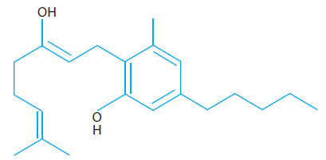  - Why do sports persons often fall a victim to cocaine addiction?  Ans: ________________________________________________________________________________________________________________________________________________________________________________________________________________________________________________________________________________________________________________________________________  - Why sharing of injection needles between two individuals is not recommended?  Ans: _________________________________________________________________________________________________________________________________________________________________________________________________________________________________________________________________________________________________________________________________________________________________________________  - Mention the useful as well as the harmful drug obtained from the latex of Poppy plant.  Ans: ___________________________________________________________________________________________________________________________________________________________________________________________________________________________________________________________________________________________________________________________________ | 3
14. | Given below is the flow chart for cell mediated immune response.  Invading pathogen  Macrophage presents antigen  T-helper cells recognise antigen and produces T-lymphocytes memory cells  Killer T-cell suppressor cell Memory cells  Answer the following questions on the basis of the flow chart:  - Name any two types of cells which act as ‘Cellular Barriers’ to provide Innate Immunity inhumans.  Ans: __________________________________________________________________________________  - Thymus of a new born child was degenerating right from birth due to a genetic disorder.Predict its two impacts on the health of the child.  Ans: __________________________________________________________________________________  (iii) How do cytokine barriers provide innate immunity in humans?  Ans: _________________________________________________________________________________________________ | 3

Work sheet chapter 8: “MICROBES IN HUMAN WELFARE”
CLASS : XII SUBJECT: BIOLOGY
ROLL NO. _______NAME : ____________ DATE: ___/____/___

TIME:30 MINUTES MM:20 MARKS OBTAINED________
Section “A” Multiple Choice Questions (MCQ) and Assertion Reason type questions Choose the correct option for each question.
Q. 1 A nitrogen fixing microbe associated with the fern Azolla in rice fields is
(a) Frankia (b) Rhizobium
(c) Spirulina (d) Anabaena

Q.2.The vitamin whose content increases following the conversion of milk into curd by lactic acid bacteria is
(a) vitamin C (b) vitamin D
(c) vitamin B₁₂ (d) vitamin E
Q.3.Methanogenic bacteria are not found in
(a) rumen of cattle (b) gobar gas plant
(c) bottom of water-logged paddy field (d) activated sludge
Q.4.The primary treatment of wastewater involves the removal of
(a) dissolved impurities (b) stable particles
(c) toxic substances (d) harmful bacteria
Q. 5 BOD of wastewater is estimated by measuring the amount of
(a) total organic matter (b) biodegradable organic matter
(c) oxygen evolution (d) oxygen consumption
Q.6.Which one of the following is not a nitrogen-fixing organism ?
(a) Anabaena (b) Nostoc
(c) Azotobacter (d) Pseudomonas
Q.7.Which of the following organisms is used in the production of beverages ?
(a) Penicillium notatum (b) Saccharomyces cerevisiae
(c) Aspergilus niger (d) Clostridium butylicum
Directions:- In the following questions, a statement of assertion is followed by a statement of reason. Mark the correct choice as: (1X3=3)
- If both Assertion and Reason are true and Reason is the correct explanation of Assertion.
- If both Assertion and Reason are true but Reason is not the correct explanation of Assertion.
- If Assertion is true but Reason is false.
- If both Assertion and Reason are false.

Q.8.Assertion: Besides curdling of milk, LAB also improve its nutritional quality by increasing vitamin- B12.
Reason: LAB, when present in human stomach, check disease causing microbes.

Ans

Q.9.Assertion: Streptococcus thermophilus increases nutritional value of milk.
Reason: Milk has lesser vitamin content than curd and yoghurt

Ans

Q.10.Assertion: Beer and wine are called soft liquors while gin, rum, etc. are hard liquors.
Reason: Beer and wine are made without distillation.

Ans

Section:- “B” Very short, short answer type questions.

Q. 11 Give the scientific name of the source organisms from which the first antibiotic was produced.
Ans. __________________________________________________________________________________________________________________________________________________________________________________________________________________________________________________________________

Q.12.Name the gas released and the process responsible for puffing up of the bread dough when Saccharomyces cerevisiae is added to it. (1)
Answer: _______________________________________________________________________________________________________________________________________________________________________________________________________________________________________

Q.13.Mention the information that the health workers derive by measuring BOD of a water body. (1)

Answer: ___________________________________________________________________________________________________________________________________________________________________________________________________________________________________
Q.14.Why do we add an inoculum of curd to milk for curdling it? (1)
Answer: ___________________________________________________________________________________________________________________________________________________________________________________________________________________________________________________________________________________________________________
Q.15.Mention a product of human welfare obtained with the hel

of each one of the following microbes. (1)
- LAB
- Saccharomyces cerevisiae
- Propionibacterium shermanii
- Aspergillus niger

ANSWER:_________________________________________________________________________________________________________________________________________________________________________________________________________________________________________________________________________________________________________________________________________________________________________________________________________________________________________________________________________________
Q.16.Name the source of cyclosporin-A. How does this bioactive molecule function in our body? (2)
Answer:- _______________________________________________________________________________________________________________________________________________________________
Q.17.State the medicinal value and the bioactive molecules produced by Penicillium notatum, Monascus perpureus and Trichoderma polysporum (3)
Answer:- _________________________________________________________________________________________________________________________________________________________________________________________________________________________________________________________________________________________________________________________________________________________________________________________________________________________________________________________________________________________________________________________________________________________________________________________________________________________________________________________________________________

Work sheet chapter 9: “Biotechnology: Principles & Processes”

CLASS : XII SUBJECT: BIOLOGY

ROLL NO. _______NAME : ____________ DATE: ___/____/___

TIME:30 MINUTES MM:20 MARKS OBTAINED________

QN. | QUESTIONS | MM
1. | A student wants to develop a colony ofE.Coli possessing plasmid pBR 322 which is sensitive to tetracyclin. Which restriction site he should use to insert a foreign DNA?  - HIND III b. Sal I c.PvuI d. ECoRI | 1
2. | Write the conditions for movement of DNA fragments on agarose gel during gel electrophoresis.  - Larger the fragment farther it will move  - Smaller the fragment farther it will move  - Negatively charged fragment will not move  - Positively charged fragment will move farther | 1
3. | Restriction endonuclease enzymes are called as molecular scissors because  - They can cleave one or both the strands of DNA.  - They act on single stranded DNA only.  - They cleave DNA base pairs at ends only.  - They cleave RNA fragments only. | 1
4. | The nomenclature of the pBR322 plasmid is as stated below: P – Plasmid, BR - Stands for Bolivar and Rodriguez who constructed this plasmid, 322 - Number given to distinguish this plasmid from the other plasmids developed in the same laboratory.  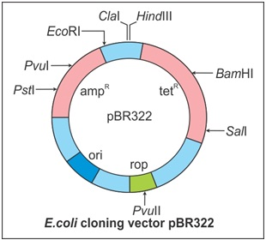  - Plasmid pBR322 has two resistance genes—ampicillin resistance (ampR) and tetracycline resistance (tetR)—which are considered useful for selectable markers.  - Plasmid pBR322 has a variety of unique recognition sites for restriction endonucleases.  - Two unique sites—PstI and PvuI—are located within the ampR gene and BamHI and SalI are within the tetR gene.  (i) Antibiotic resistant gene in a vector is called selectable marker because it hepls in selection of……………………………………………………………………………………………………………………………………………………………………………………………………………………………………………  (ii) What is the importance of ori site shown in figure?  ………………………………………………………………………………………………………………………………………………………………………………………………………………………………………………….. | 2

5. | Directions: In the following questions, a statement of assertion is followed by a statement of reason.  Mark the correct choice as:  (a) If both Assertion and Reason are true and Reason is the correct explanation of Assertion.  (b) If both Assertion and Reason are true but Reason is not the correct explanation of Assertion.  (c) If Assertion is true but Reason is false.  (d) If both Assertion and Reason are false.  (i). Assertion: β- galactosidase coding sequence acts as a selectable marker.  Reason: This gene produces enzyme, which is involved in chromogenic reaction.  Answer: …………………………………………………………………………………..  (ii). Asertion: E. coli bacteria which is having an insert at Bam HI site of it’s plasmid pBR322 can’t grow in tetracyclin medium.  Reason: The recognition sire for Bam HI is present in tetracyclin resistance gene of Pbr322.  Answer: …………………………………………………………………………………..  2
6. | Towards which electrode DNA fragments move during gel electrophoresis? Why?  Answer: ………………………………………………………………………………………………………………………………………………………………………………………………………………………………………………………………………………………………………………………………………………………………………………………………  2
7. | Action of which restriction enzyme (A) is shown in the process shown below ? What type of ends are shown by B? State importance of this type of cut in DNA fragments.  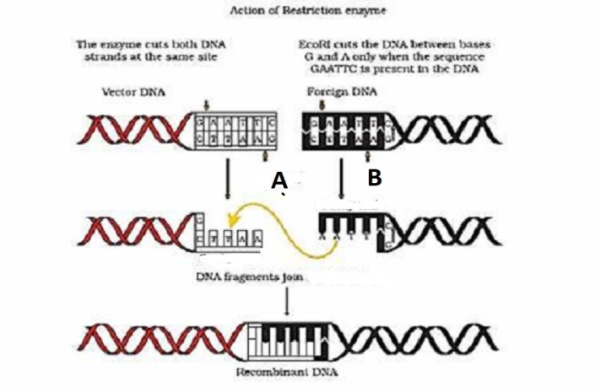  Answer:……………………………………………………………………………………  ………………………………………………………………………………………….  ………………………………………………………………………………………………  ………………………………………………………………………………………………  ………………………………………………………………………………………………  2

8. | Which is the most commonly used bioreactor in biotech labs. Mention any 2 important characters of this bioreactor.  Answer: ……………………………………………………………………………………………………………………………………………………………………………………………………………………………………………………………………………………………… | 3
9. | Observe the figure given below and answer the questions:  - Which processes is shown by A?  - Identify enzyme B and it’s source.  - State importance of above enzyme?  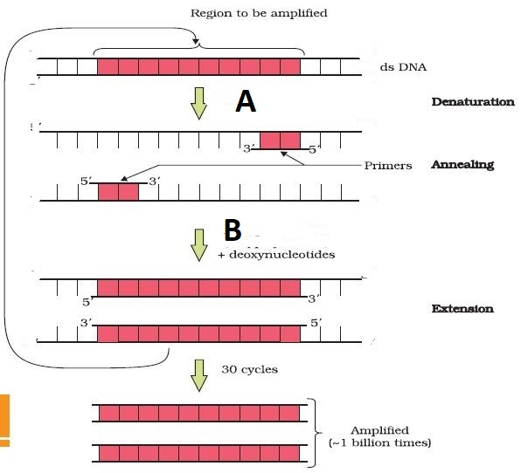  Answer(i)……………………………………………………………………………….  (ii)…………………………………………………………………………………………  (iii)………………………………………………………………………………………………………………………………………………………………………………………… | 3
1`0. | (i)What is insertional inactivation?  Answer: ………………………………………………………………………………………………………………………………………………………………………………………………………………………………………………………………………………………………  (ii) . Why insertional inactivation is said to be better method to detect recombinants, than use of selectable markers.  Answer: ……………………………………………………………………………………………………………………………………………………………………………………………………………………………………………………………………………………………… | 3

Work sheet chapter 10: “Biotechnology & Its Applications”
CLASS : XII SUBJECT: BIOLOGY
ROLL NO. _______NAME : ____________ DATE: ___/____/___

TIME:30 MINUTES MM:20 MARKS OBTAINED________
1 | The genetically modified brinjal in India has been developed for  A. Drought resistance B. Enhancing mineral content  C. Enhancing shelf life D. Insect resistance | 1
2 | Which kind of therapy was given in 1990 to a four-year-old girl with ADA deficiency? (Adenosine Deaminase)  A. Radiation Therapy B. Gene Therapy  C. Radiation Therapy D. Immunotherapy | 1
3 | The genetically modified brinjal in India has been developed for  A. Enhancing mineral content B. Insect-resistance  C. Drought resistance D. Enhancing selflife | 1
4 | The maximum number of existing transgenic animals is of _____  A. Fish B. Mice C. Cow D. Pig | 1
5 | The process of RNA interference has been used in the development of plants resistant to _____  A. Insects B. Nematodes C. Fungi D. Viruses | 1
6 | The first ever human hormone produced by recombinant DNA technology is _____  A. Progesterone B. Insulin C. Estrogen D. Progesterone | 1
7 | Bt cotton, the Bt toxin present in plant tissue as pro-toxin in converted into active toxin due to _____  A. Acidic pH of the insect gut B. Alkaline pH of the insect gut  C. Presence of conversion factors in insect gut D. Action of gut microorganisms | 1
8 | Cry-I endotoxins obtained from Bacillus thuringiensis are effective against ___  A. Nematodes B. Flies C. Mosquitoes D. Boll worms | 1
9 | Which of the following is not used as a biopesticide?  A. Xanthomonascampestris B. Bacillus thuringiensis1  C. Trichoderma harzianum D. Nuclear Polyhedrosis V1irus | 1
10 | Transgenic food crop which may help in solving the problem of night blindness in developing countries is _______  A. Golden Rice B. FlavrSavr tomatoes C. BT soybean D. Starlink maize | 1
 | Directions: In the following questions, a statement of assertion is followed by a statement of reason.  Mark the correct choice as:  (a) If both Assertion and Reason are true and Reason is the correct explanation of Assertion.  (b) If both Assertion and Reason are true but Reason is not the correct explanation of Assertion.  (c) If Assertion is true but Reason is false.  (d) If both Assertion and Reason are false. | 1
11 | Assertion: ‘Cry’ proteins are named so because they are crystal proteins.  Reason: In acidic environment of insect midgut ‘Cry’ proteins are solubilized and then release toxic core fragments after proteolytic action.  Ans----------------------------------------------- | 1
12 | Assertion: Cry gene expressing crop is resistant to a group of insects.  Reason: Cry proteins produced from Bacillus thuringiensis are toxic to larvae of certain insects.  Ans------------------------------------------- | 1
13 | Assertion : Transgenic plant is a product of plant tissue culture.  Reason : An organism that contains and expresses a transgenic organism.  ANS------------------------- | 1
14 | Assertion : A crop expressing a cry gene is usually resistant to a group of insects.  Reason : Cry proteins produced from Bacillus thuringiensis is toxic to larvae of certain insects.  Ans----------------------------- | 1
15 | Assertion :FlavrSavr, a transgenic tomato which remains fresh and retains their flavour for long time.  Reason : Production of polygalacturonase enzyme, which degrades pectin, is blocked in FlavrSavr.  Ans-------------------------- | 1
16 | Write the two specific ‘cry’ genes that encode the proteins which control cotton boll worms.  -------------------------------------------------------------------------------------------- | 1
17 | Mention the chemical change that proinsulin undergoes, to be able to act as mature insulin. | 1
18 | What are cry genes? In which organisms are they present?  --------------------------------------------------------------------- | 1
19 | Suggest any two possible treatments that can be given to patient exhibiting adenosine deaminase deficiency. | 1
20 | State the role of C-peptide in human insulin. | 1

Work sheet chapter 11: “ Organisms and Populations”
CLASS : XII SUBJECT: BIOLOGY
ROLL NO. _______NAME : ____________ DATE: ___/____/___

TIME:30 MINUTES MM:20 MARKS OBTAINED________

Q.NO. | QUESTION | M M
1. | Which of the following is a characteristic of biological community?  (a) Startification (b) Natality (c) Morality (d) Sex-ratio  Ans - | 1
2. | The logistics population growth is expressed by the equation  (a) dNdtNr K K N– = d n (b) dtdNrN K K N– = d n  (c) dtdN = rN (d) dtdNrN N N K– = d n  Ans - | 1
3. | Cuscuta is an example of  (a) ectoparasitism (b) brood parasitims  (c) predation (d) endoparasitims  Ans - | 1
4. | A sedentary sea anemone gets attached to the shell lining of hermit crab. The association is  (a) commensalism (b) amensalism  (c) ectoparasitism (d) symbiosis  Ans- | 1
5. | Ecological niche is  (a) the surface area of the ocean  (b) an ecologically adapted zone  (c) the physical position and functional role of a species within the community  (d) formed of all plants and animals living at the bottom of a lake  Ans - | 1
6. | According to Allen’s Rule, the mammals from colder climates have  (a) shorter ears and longer limbs  (b) longer ears and shorter limbs  (c) longer ears and longer limbs  (d) shorter ears and shorter limbs  Ans- | 1
7. | At which point in the graph shown below would there be zero population growth (DN/Dt = 0)?  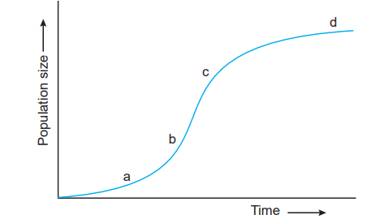  (a) a (b) b (c) c (d) d  Ans- | 1
8. | Amensalism is an association between two species where  (a) one species is harmed and other is benefitted  (b) one species is harmed and other is unaffected  (c) one species is benefitted and other is unaffected  (d) both the species are harmed.  Ans - | 1
In the following questions a statement of assertion followed by a statement of reason is given. Choose the correct answer out of the following choices.
(a) Assertion and reason both are correct statements and reason is correct explanation for assertion.
(b) Assertion and reason both are correct statements but reason is not correct explanation for assertion.
(c) Assertion is correct statement but reason is wrong statement.
(d) Assertion is wrong statement but reason is correct statement.
9. | Assertion : Leaf butterfly and stick insect show mimicry to dodge their enemies.  Reason : Mimicry is a method to acquire body colour blending with the surroundings.  Ans – | 1
10. | Assertion : Verhulst-Pearl Logistic growth curve is sigmoid in nature.  Reason : A population growing in habitat with limited resources shows an initial lag phase, followed by acceleration and deceleration and finally an asymptote.  Ans – | 1
11. | Why the plants that inhabit a desert are not found in a mangrove? Give reasons.  Ans – | 2
12 | Explain brood parasitism with the help of an example.  Ans- | 2
13 | . Identify the curves ‘a’ and ‘b’ shown in the graph given below. List the conditions responsible for growth patterns ‘a’ and ‘b’.  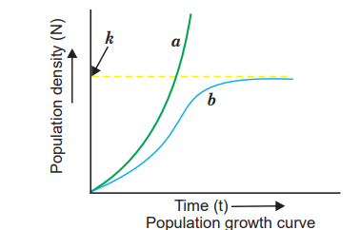  Ans – | 3
14 | Besides acting as ‘conduits’ for energy transfer across trophic levels, predators play other important roles. Justify.  Ans – | 3
Work sheet chapter 12: “ Ecosystem”
CLASS : XII SUBJECT: BIOLOGY
ROLL NO. _______NAME : ____________ DATE: ___/____/___

TIME:30 MINUTES MM:20 MARKS OBTAINED________
Q.NO. | QUESTION | M M
1. | Mass of living matter at a trophic level in an area at any time is called  (a) standing crop (b) detritus (c) humus (d) standing state  Ans - | 1
2. | Identify the possible link “A” in the following food chain. Plant → insect → frog →“A”→ eagle  (a) rabbit (b) wolf (c) cobra (d) parrot  Ans - | 1
3. | Which one of the following is not a functional unit of an ecosystem?  (a) Energy flow (b) Decomposition  (c) Productivity (d) Stratification  Ans - | 1
4. | The upright pyramid of number is absent in  (a) pond (b) forest (c) lake (d) grassland  Ans - | 1
5. | The process of mineralisation by microorganisms helps in the release of [NCERT Exemplar]  (a) inorganic nutrients from humus  (b) both organic and inorganic nutrients from detritus  (c) organic nutrients from humus  (d) inorganic nutrients from detritus and formation of humus.  Ans - | 1
6. | Which of the following type of ecosystem is expected in an area where evaporation exceeds precipitation, and mean annual rainfall is below 100 mm?  (a) Grassland (b) Shrubby forest (c) Desert (d) Mangrove  Ans - | 1
7. | Pyramid of energy is  (a) always upright (b) always inverted  (c) either upright or inverted (d) neither upright nor inverted  Ans - | 1
8. | Productivity is the rate of production of biomass expressed in terms of  (i) (kcal m–3) yr–1 (ii) g–2 yr–1 (iii) g–1 yr–1 (iv) (kcal m–2) yr–1  (a) (ii) (b) (iii) (c) (ii) and (iv) (d) (i) and (iii)  Ans - | 1
In the following questions a statement of assertion followed by a statement of reason is given. Choose the correct answer out of the following choices.
(a) Assertion and reason both are correct statements and reason is correct explanation for assertion.
(b) Assertion and reason both are correct statements but reason is not correct explanation for assertion.
(c) Assertion is correct statement but reason is wrong statement.
(d) Assertion is wrong statement but reason is correct statement.
9. | Assertion : A network of food chains existing together in an ecosystem is known as a food web.  Reason : An animal like kite cannot be part of a food web.  Ans – | 1
10. | Assertion : Net primary productivity is gross primary productivity minus respiration.  Reason : Secondary productivity is produced by heterotrophs.  Ans – | 1
11. | “It is possible that a species may occupy more than one trophic level in the same ecosystem at the same time.” Explain with the help of one example.  Ans - | 2
12 | Why is earthworm considered a farmer’s friend? Explain humification and mineralisation occurring in a decomposition cycle.  Ans - | 2
13 | Compare the two ecological pyramids of biomass given below and explain the situations in which this is possible. Also, construct an ideal pyramid of energy, if 200,000 joules of sunlight is available.  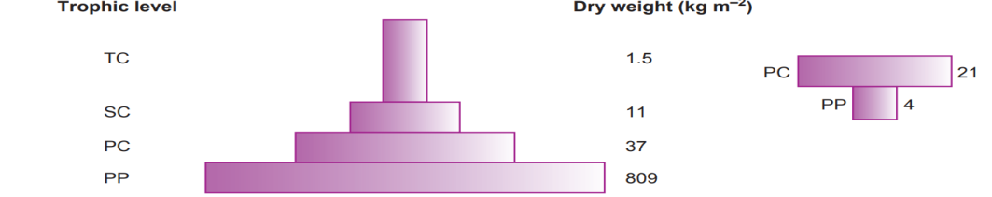  Ans – | 3
14 | Describe the inter-relationship between productivity, gross primary productivity and net productivity.  Ans - | 3
Work sheet chapter 13: “ Ecosystem”
CLASS : XII SUBJECT: BIOLOGY
ROLL NO. _______NAME : ____________ DATE: ___/____/___

TIME:30 MINUTES MM:20 MARKS OBTAINED________
Q.NO. | QUESTION | M M
1. | Which one of the following pairs of organisms are exotic species introduced in India?  (a) Lantana camara, water hyacinth  (b) Water hyacinth, Prosopiscinereria  (c) Nile perch, Ficusreligiosa  (d) Ficusreligiosa, Lantana camara  Ans - | 1
2. | Which one of the following is not observed in biodiversity hot spots?  (a) Lesser inter-specific competition  (b) Species richness  (c) Endemism  (d) Accelerated species loss  Ans - | 1
3. | A collection of plants and seed having diverse alleles of all the genes of a crop is called  (a) herbarium (b) germplasm (c) gene library (d) genom  Ans- | 1
4. | Biodiversity of a geographical region represents  (a) endangered species found in the region  (b) the diversity in the organisms living in the region  (c) genetic diversity in the dominant species of the region  (d) species endemic to the region  Ans - | 1
5. | The one-horned rhinoceros is specific to which of the following sanctuary?  (a) BhitarKanika (b) Bandipur (c) Kaziranga (d) Corbett park  Ans - | 1
6. | Keystone species deserve protection because these  (a) are capable of surviving in harsh environmental condition  (b) indicate presence of certain mineral in the soil.  (c) have become rare due to overexploitation.  (d) play an important role in supporting other species.  Ans- | 1
7. | Which of the following group exhibit more species diversity?  (a) Gymnosperms (b) Algae (c) Bryophytes (d) Fungi  Ans - | 1
8. | What is common to the techniques (i) in vitro fertilisation, (ii) Cryopreservation and (iii) tissue culture?  (a) All are in situ conservation methods.  (b) All are ex situ conservation methods.  (c) All require ultra-modern equipment and large space.  (d) All are methods of conservation of extinct organisms.  Ans - | 1
In the following questions a statement of assertion followed by a statement of reason is given. Choose the correct answer out of the following choices.
(a) Assertion and reason both are correct statements and reason is correct explanation for assertion.
(b) Assertion and reason both are correct statements but reason is not correct explanation for assertion.
(c) Assertion is correct statement but reason is wrong statement.
(d) Assertion is wrong statement but reason is correct statement.
9. | Assertion : Tropical rainforests are disappearing fast from developing countries like India.  Reason : No value is attached to these forests because they are poor in biodiversity.  Ans - | 1
10. | Assertion : Traditionally, sacred groves acted as repository for various medicines.  Reason : In modern times, sacred groves have become biodiversity rich areas.  Ans - | 1
11. | What is IUCN red list? Give any two uses of this list.  Ans- | 2
12 | Why are conventional methods not suitable for the assessment of biodiversity of bacteria?  Ans - | 2
13 | 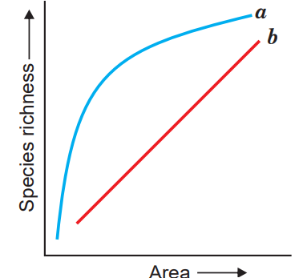  The given graph alongside shows species–area relationship. Write the equation of the curve ‘a’ and explain.  Ans- | 3
14 | There are many animals that have become extinct in the wild but continue to be maintained in Zoological parks. (i) What type of biodiversity conservation is observed in this case? (ii) Explain any two other ways which help in this type of conservation.  Ans- | 3

